# Recorded Steps

This file contains all the steps and information that was recorded to help you describe the recorded steps to others.

Before sharing this file, you should verify the following:

* The steps below accurately describe the recording.
* There is no information below or on any screenshots that you do not want others to see.

Passwords or any other text you typed were not recorded, except for function and shortcut keys that you used.

You can do the following:

* Review the recorded steps
* [Review the recorded steps as a slide show](./slide0001.htm)
* Review the additional details

# Steps

[Next](#Step2" \o "Next)

**Step 1: (‎30/‎03/‎2023 14:51:07)** User left click on "Firefox (button)"

*No screenshots were saved for this step.*

[Previous](#Step1" \o "Previous) [Next](#Step3" \o "Next)

**Step 2: (‎30/‎03/‎2023 14:51:09)** User left click on "Google — Mozilla Firefox (window)" in "Google — Mozilla Firefox"

*No screenshots were saved for this step.*

[Previous](#Step2" \o "Previous) [Next](#Step4" \o "Next)

**Step 3: (‎30/‎03/‎2023 14:51:12)** User keyboard input on "Google — Mozilla Firefox (window)" in "Google — Mozilla Firefox" [... Enter]

*No screenshots were saved for this step.*

[Previous](#Step3" \o "Previous) [Next](#Step5" \o "Next)

**Step 4: (‎30/‎03/‎2023 14:51:15)** User left click in "xampp - Penelusuran Google — Mozilla Firefox"

*No screenshots were saved for this step.*

[Previous](#Step4" \o "Previous) [Next](#Step6" \o "Next)

**Step 5: (‎30/‎03/‎2023 14:51:18)** User left click in "Download XAMPP — Mozilla Firefox"

*No screenshots were saved for this step.*

[Previous](#Step5" \o "Previous) [Next](#Step7" \o "Next)

**Step 6: (‎30/‎03/‎2023 14:52:41)** User left double click on "Name (edit)" in "Programs"

*No screenshots were saved for this step.*

[Previous](#Step6" \o "Previous) [Next](#Step8" \o "Next)

**Step 7: (‎30/‎03/‎2023 14:52:51)** User left click on "OK (button)" in "Warning"

*No screenshots were saved for this step.*

[Previous](#Step7" \o "Previous) [Next](#Step9" \o "Next)

**Step 8: (‎30/‎03/‎2023 14:52:52)** User left click on "Setup (window)" in "Setup"

*No screenshots were saved for this step.*

[Previous](#Step8" \o "Previous) [Next](#Step10" \o "Next)

**Step 9: (‎30/‎03/‎2023 14:52:53)** User mouse wheel down on "Setup (window)" in "Setup"

*No screenshots were saved for this step.*

[Previous](#Step9" \o "Previous) [Next](#Step11" \o "Next)

**Step 10: (‎30/‎03/‎2023 14:52:54)** User mouse drag start on "Position (thumb)" in "Setup"

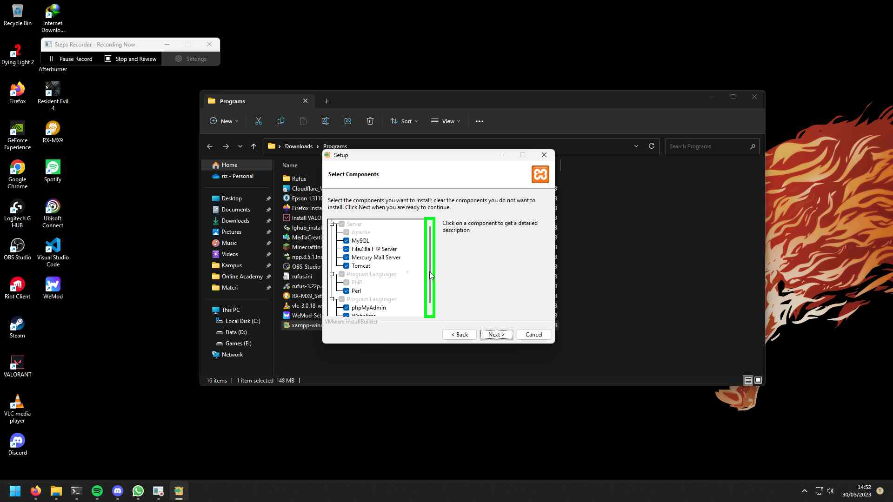Step 10 screenshot.

[Previous](#Step10" \o "Previous) [Next](#Step12" \o "Next)

**Step 11: (‎30/‎03/‎2023 14:52:55)** User mouse drag end on "Line down (button)" in "Setup"

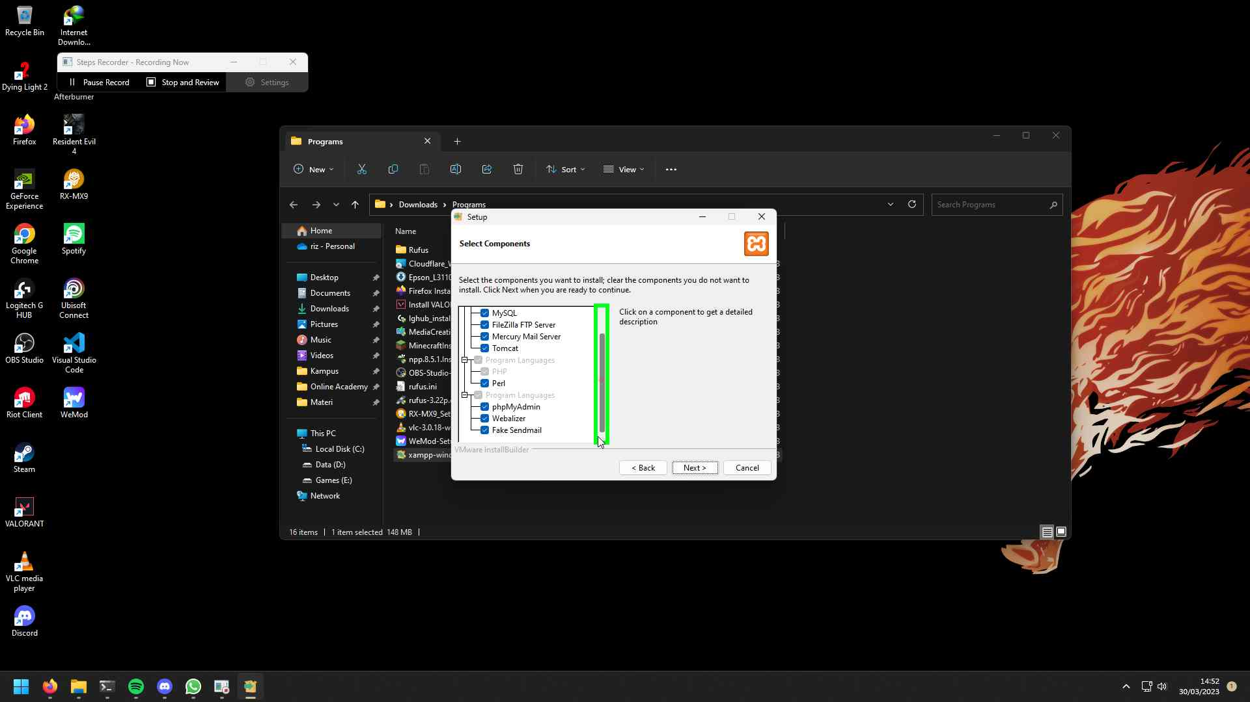Step 11 screenshot.

[Previous](#Step11" \o "Previous) [Next](#Step13" \o "Next)

**Step 12: (‎30/‎03/‎2023 14:52:56)** User left click on "Setup (window)" in "Setup"

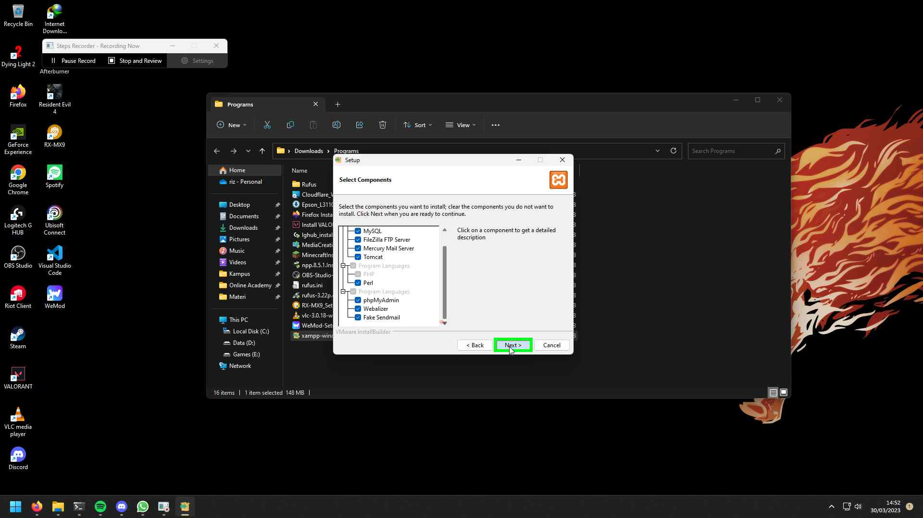Step 12 screenshot.

[Previous](#Step12" \o "Previous) [Next](#Step14" \o "Next)

**Step 13: (‎30/‎03/‎2023 14:52:58)** User left double click on "Setup (window)" in "Setup"

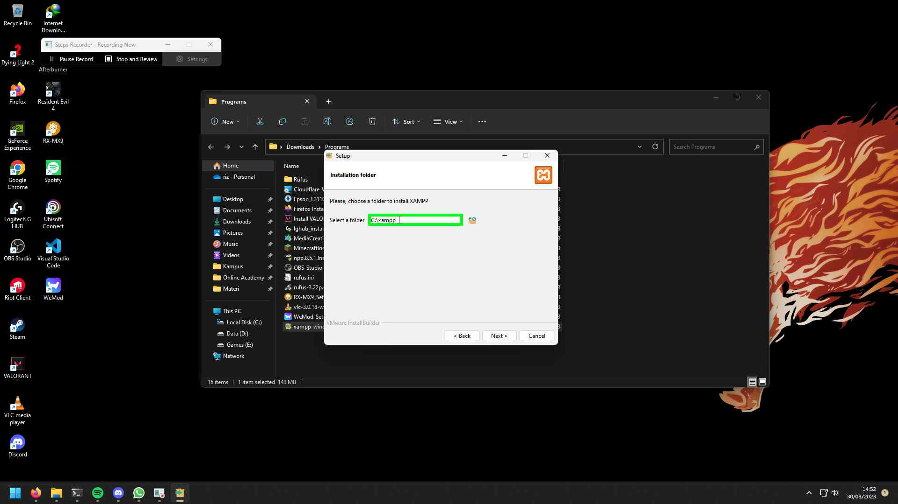Step 13 screenshot.

[Previous](#Step13" \o "Previous) [Next](#Step15" \o "Next)

**Step 14: (‎30/‎03/‎2023 14:52:59)** User mouse drag end on "Setup (window)" in "Setup"

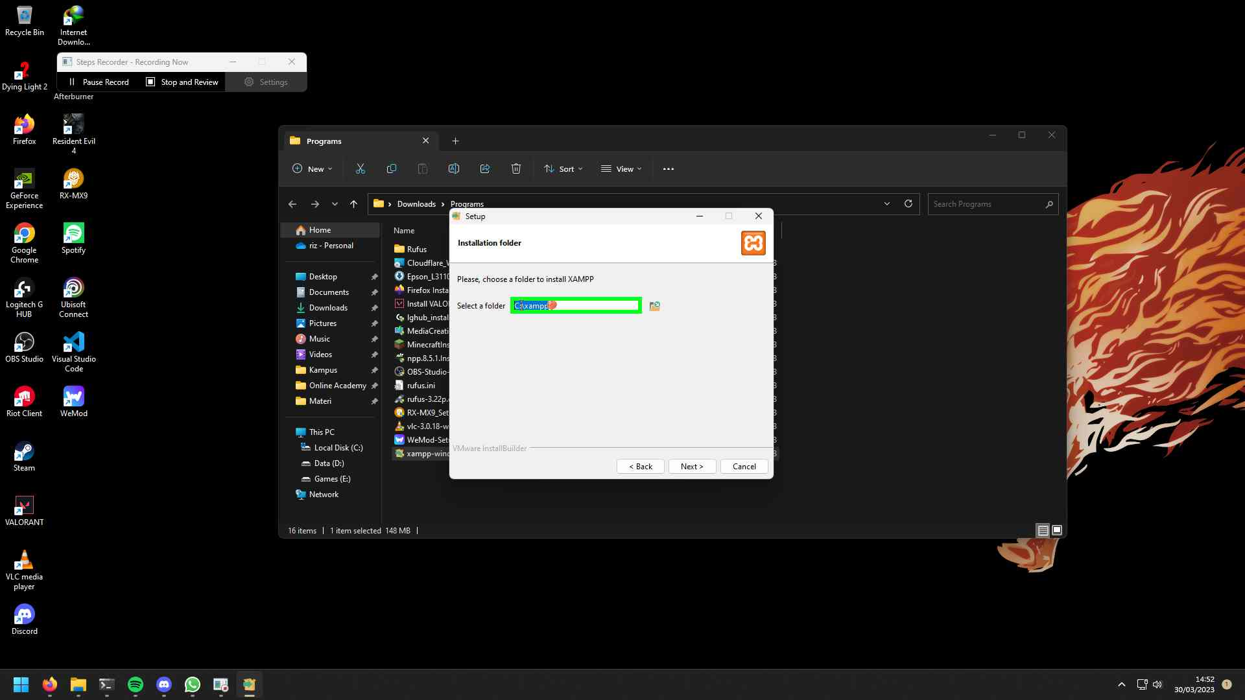Step 14 screenshot.

[Previous](#Step14" \o "Previous) [Next](#Step16" \o "Next)

**Step 15: (‎30/‎03/‎2023 14:52:59)** User left click on "Setup (window)" in "Setup"

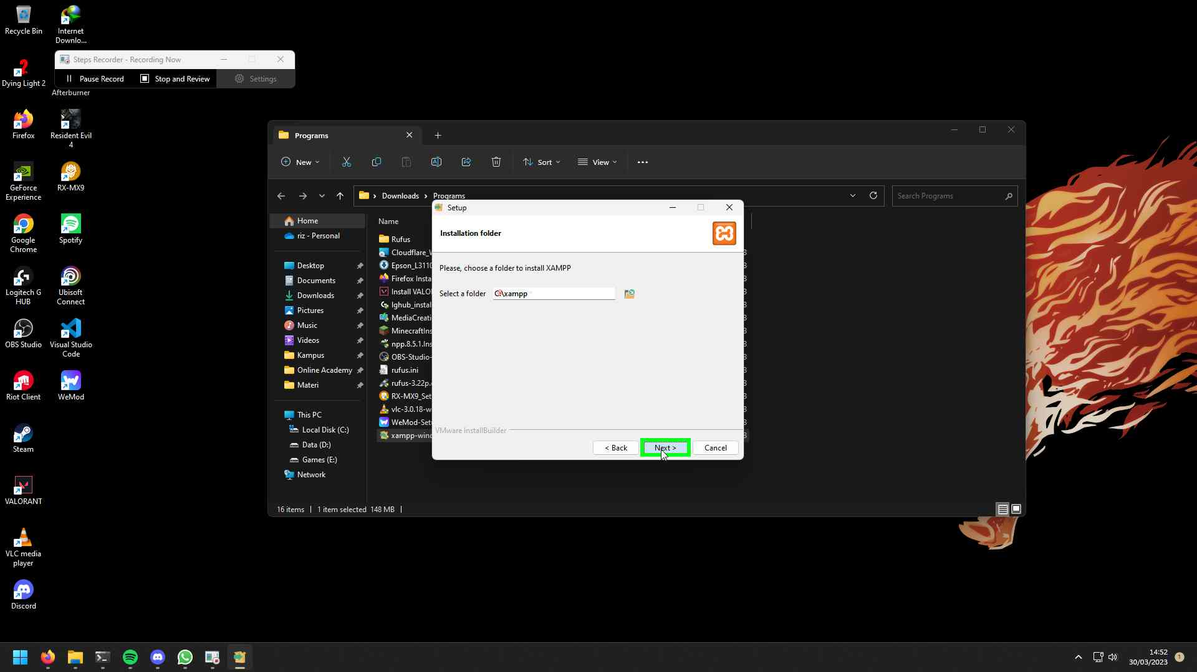Step 15 screenshot.

[Previous](#Step15" \o "Previous) [Next](#Step17" \o "Next)

**Step 16: (‎30/‎03/‎2023 14:53:01)** User left click on "Setup (window)" in "Setup"

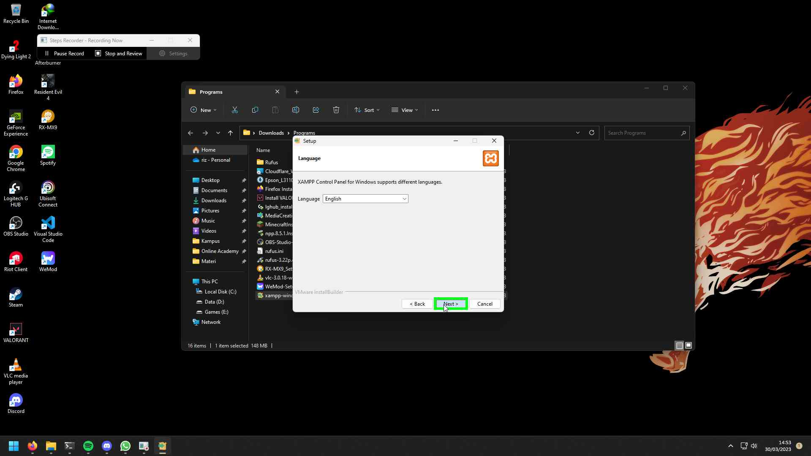Step 16 screenshot.

[Previous](#Step16" \o "Previous) [Next](#Step18" \o "Next)

**Step 17: (‎30/‎03/‎2023 14:53:02)** User left click on "Setup (window)" in "Setup"

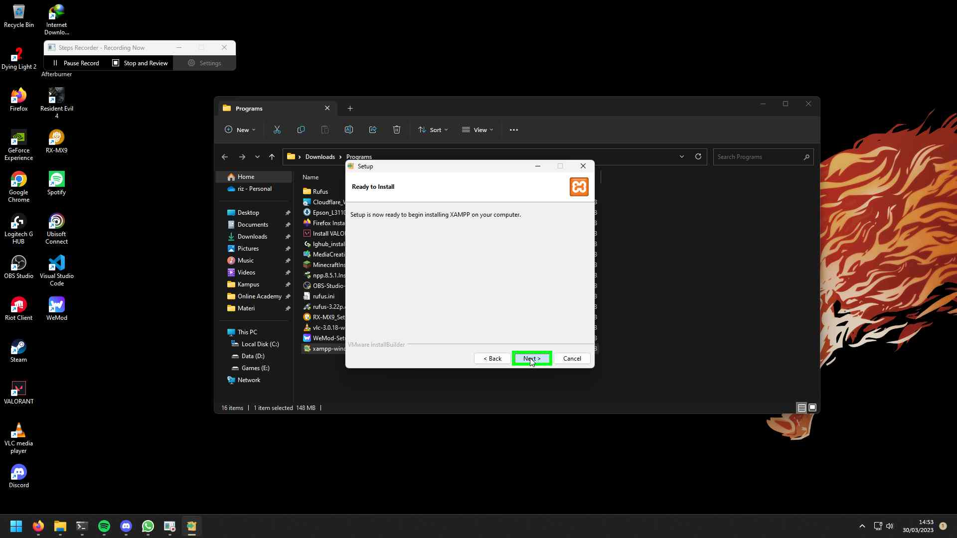Step 17 screenshot.

[Previous](#Step17" \o "Previous) [Next](#Step19" \o "Next)

**Step 18: (‎30/‎03/‎2023 14:54:32)** User left click on "Allow access (button)" in "Windows Security Alert"

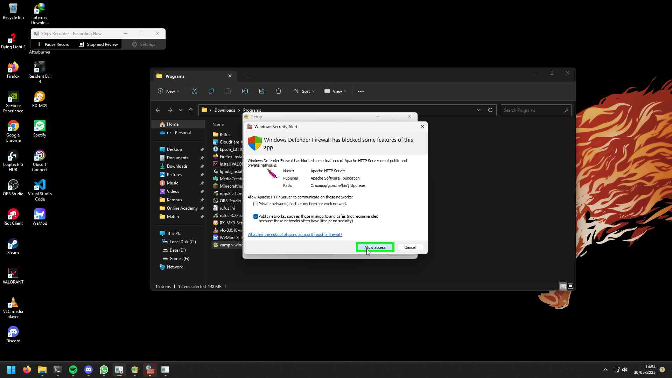Step 18 screenshot.

[Previous](#Step18" \o "Previous) [Next](#Step20" \o "Next)

**Step 19: (‎30/‎03/‎2023 14:54:45)** User left click on "Setup (window)" in "Setup"

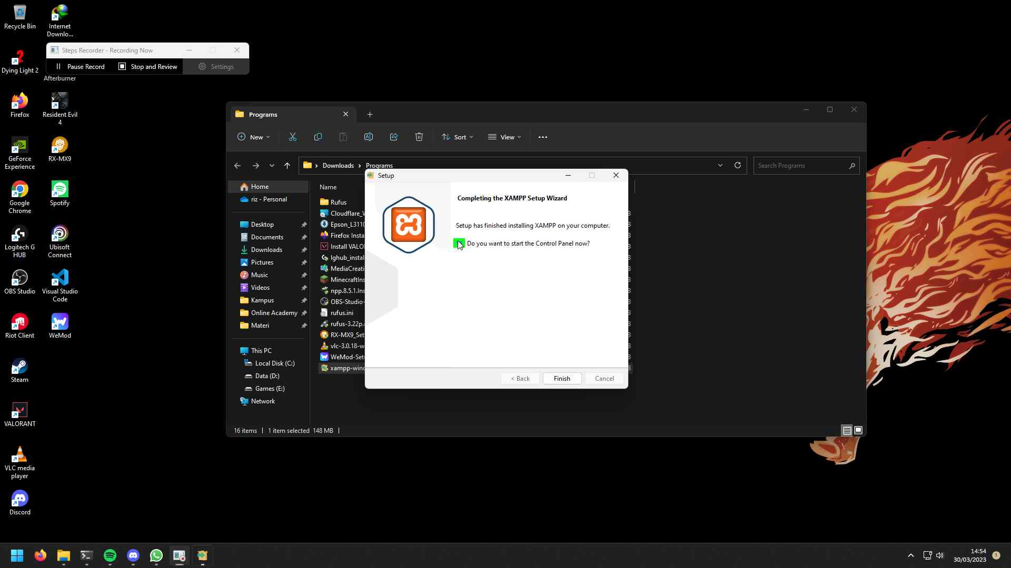Step 19 screenshot.

[Previous](#Step19" \o "Previous) [Next](#Step21" \o "Next)

**Step 20: (‎30/‎03/‎2023 14:54:46)** User left click on "Setup (window)" in "Setup"

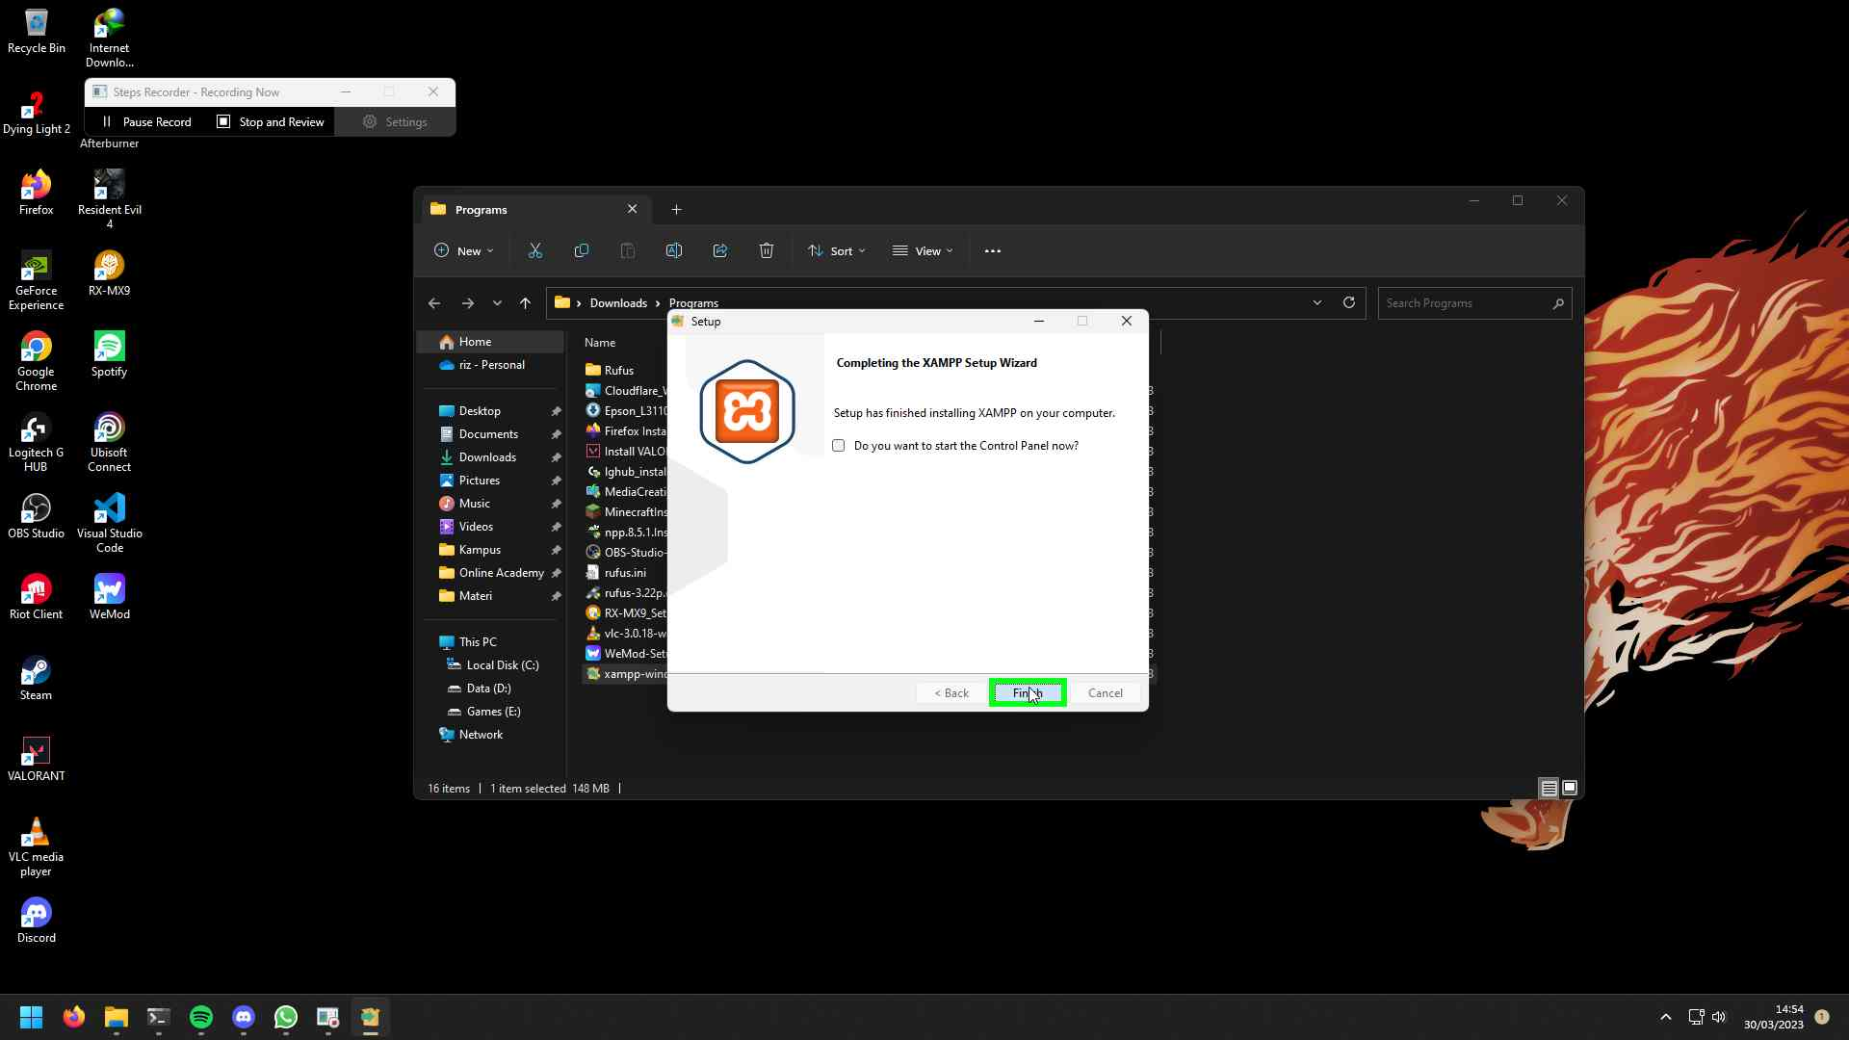Step 20 screenshot.

[Previous](#Step20" \o "Previous) [Next](#Step22" \o "Next)

**Step 21: (‎30/‎03/‎2023 14:54:48)** User left click on "Start (button)"

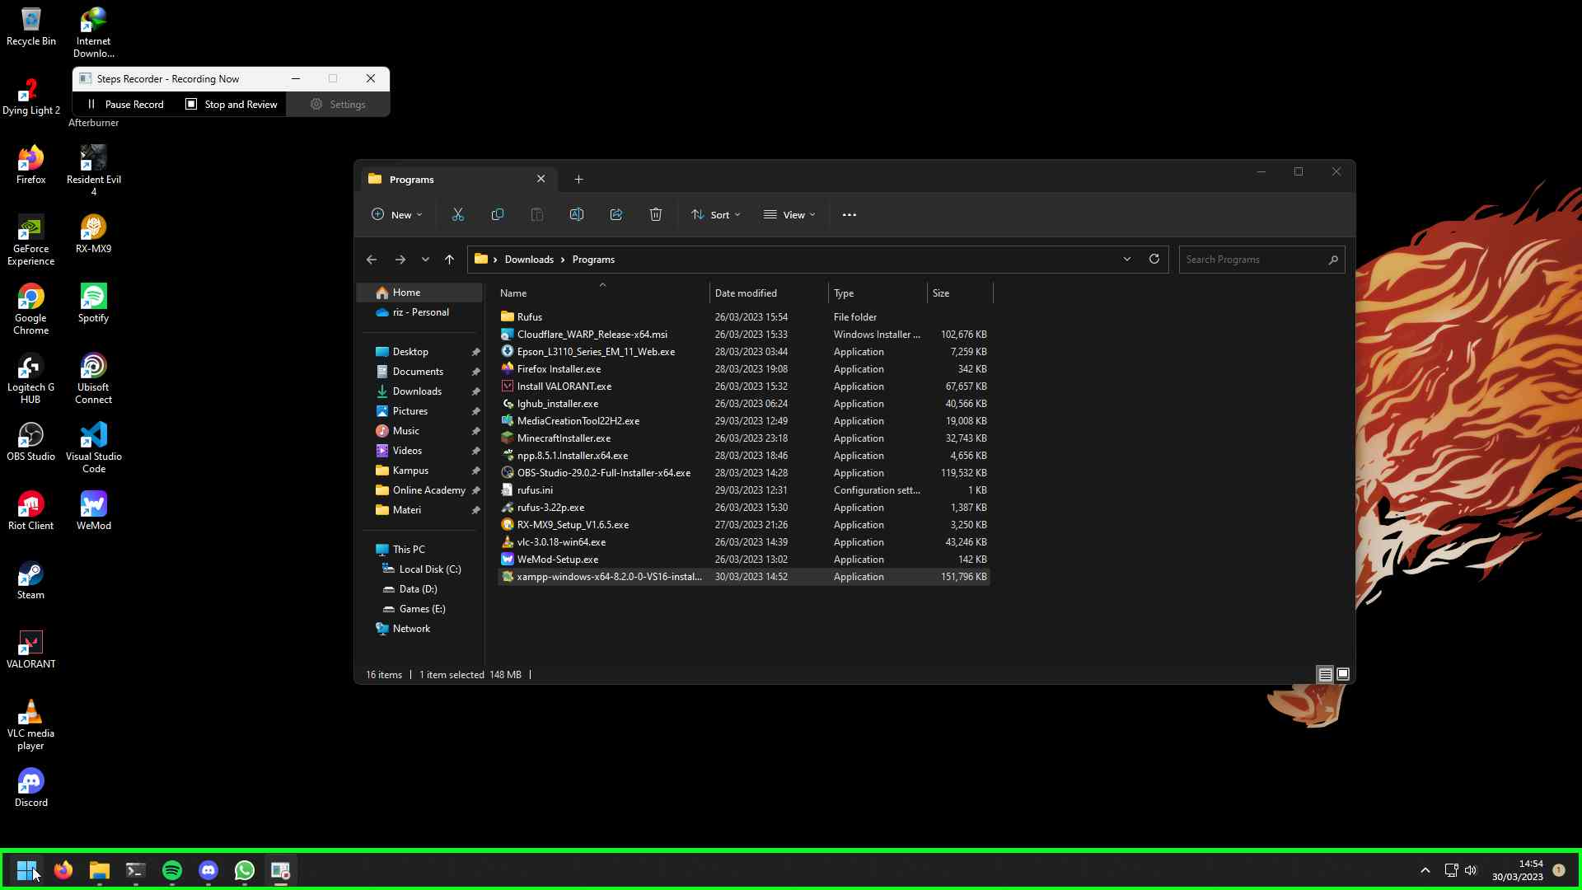Step 21 screenshot.

[Previous](#Step21" \o "Previous) [Next](#Step23" \o "Next)

**Step 22: (‎30/‎03/‎2023 14:54:49)** User keyboard input on "Search (window)" in "Search" [...]

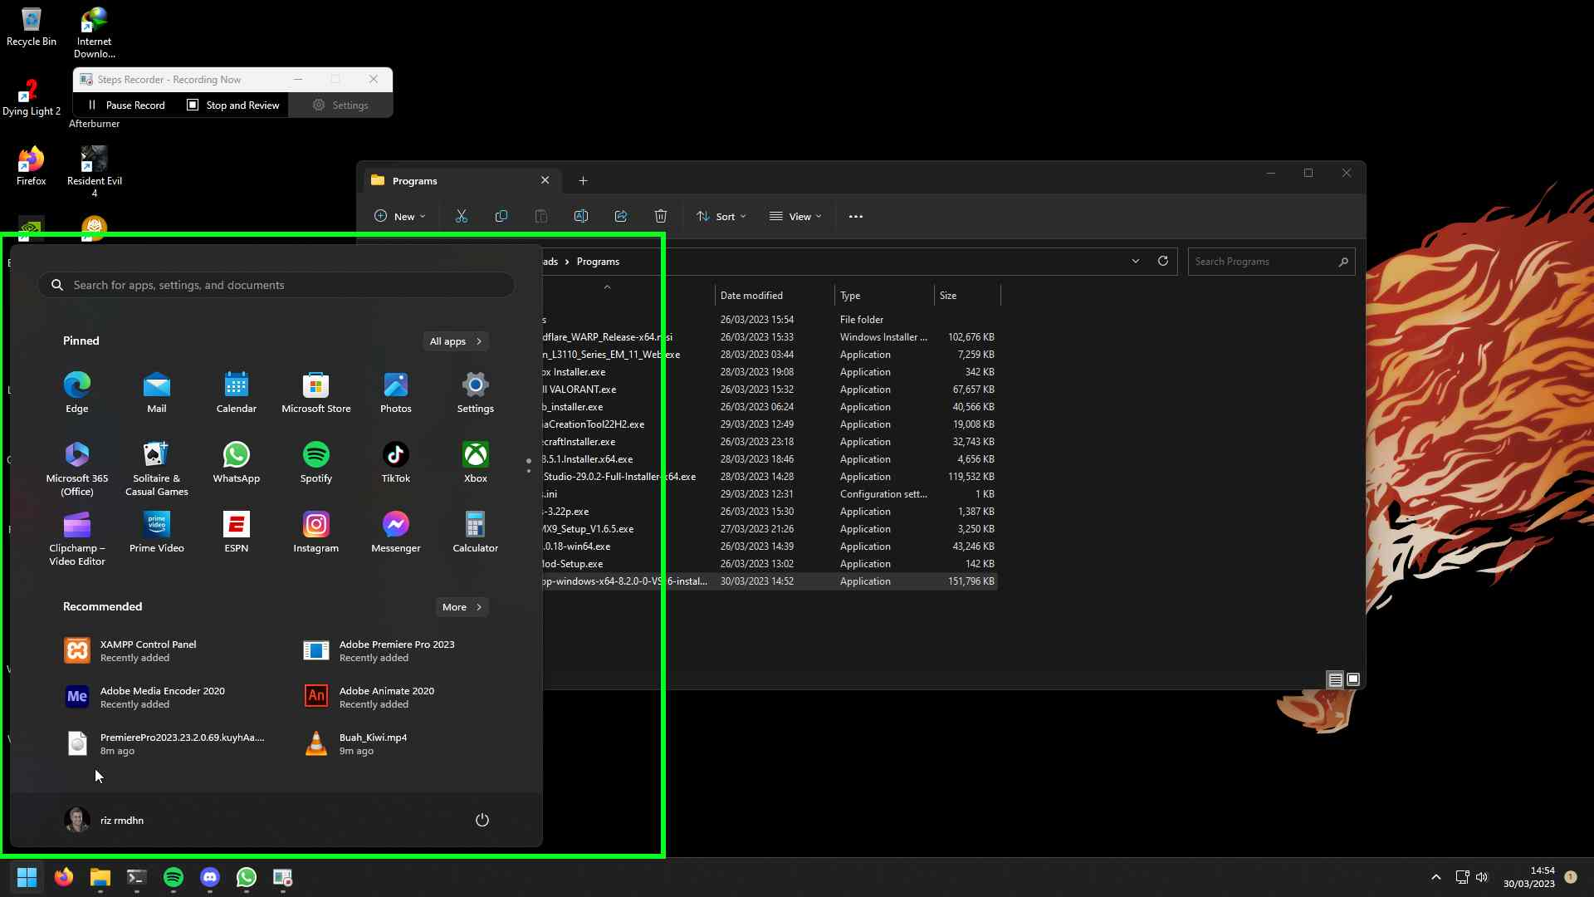Step 22 screenshot.

[Previous](#Step22" \o "Previous) [Next](#Step24" \o "Next)

**Step 23: (‎30/‎03/‎2023 14:54:51)** User right click on "XAMPP Control Panel, App, Press right to switch preview (list item)" in "Search"

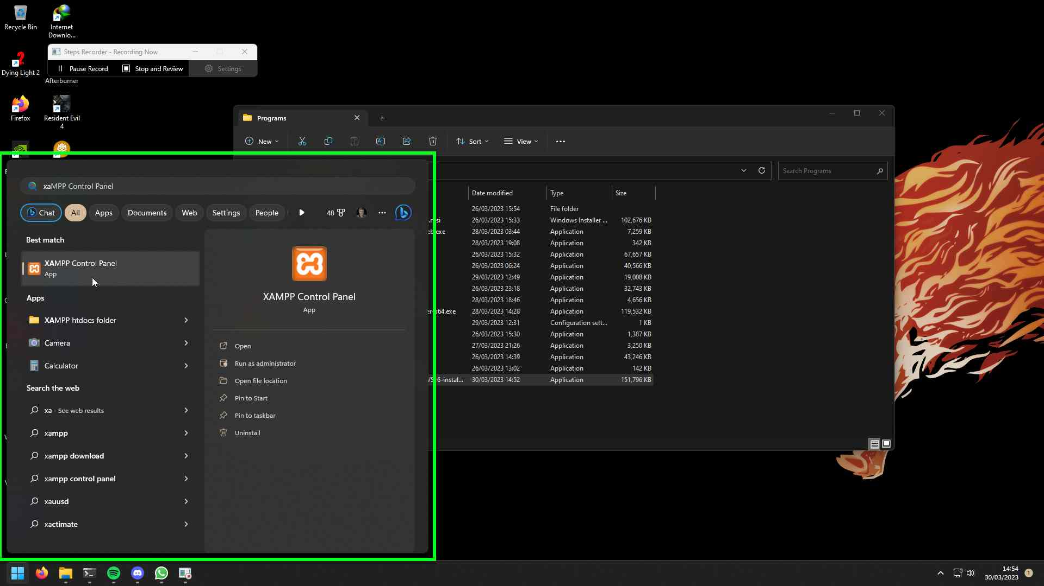Step 23 screenshot.

[Previous](#Step23" \o "Previous) [Next](#Step25" \o "Next)

**Step 24: (‎30/‎03/‎2023 14:54:52)** User left click on "Run as administrator (list item)" in "Search"

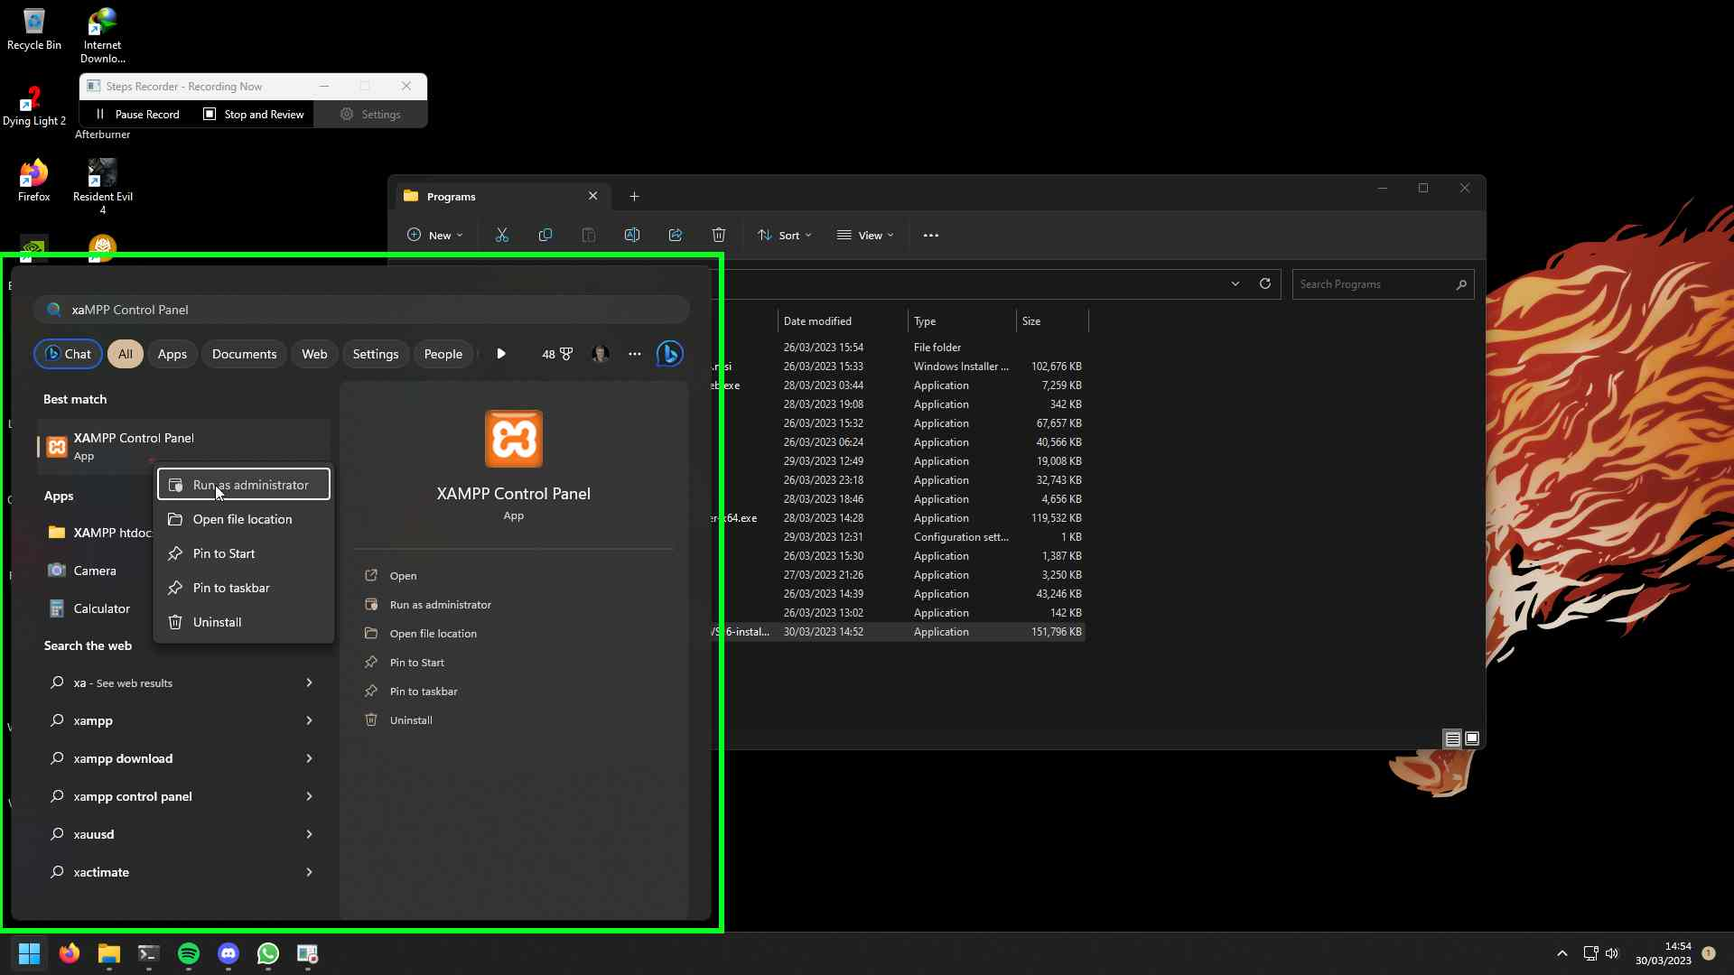Step 24 screenshot.

[Previous](#Step24" \o "Previous) [Next](#Step26" \o "Next)

**Step 25: (‎30/‎03/‎2023 14:54:58)** User left click on "Start (button)" in "XAMPP Control Panel v3.3.0 [ Compiled: Apr 6th 2021 ]"

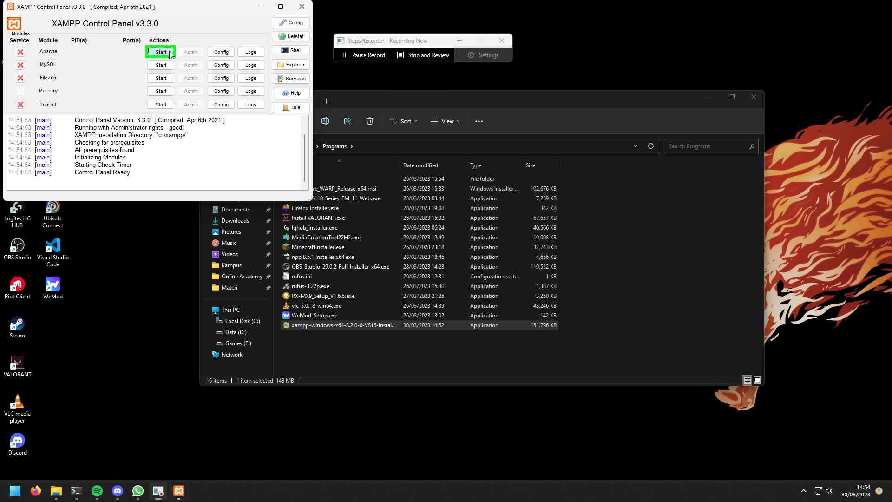Step 25 screenshot.

[Previous](#Step25" \o "Previous) [Next](#Step27" \o "Next)

**Step 26: (‎30/‎03/‎2023 14:54:59)** User left click on "Start (button)" in "XAMPP Control Panel v3.3.0 [ Compiled: Apr 6th 2021 ]"

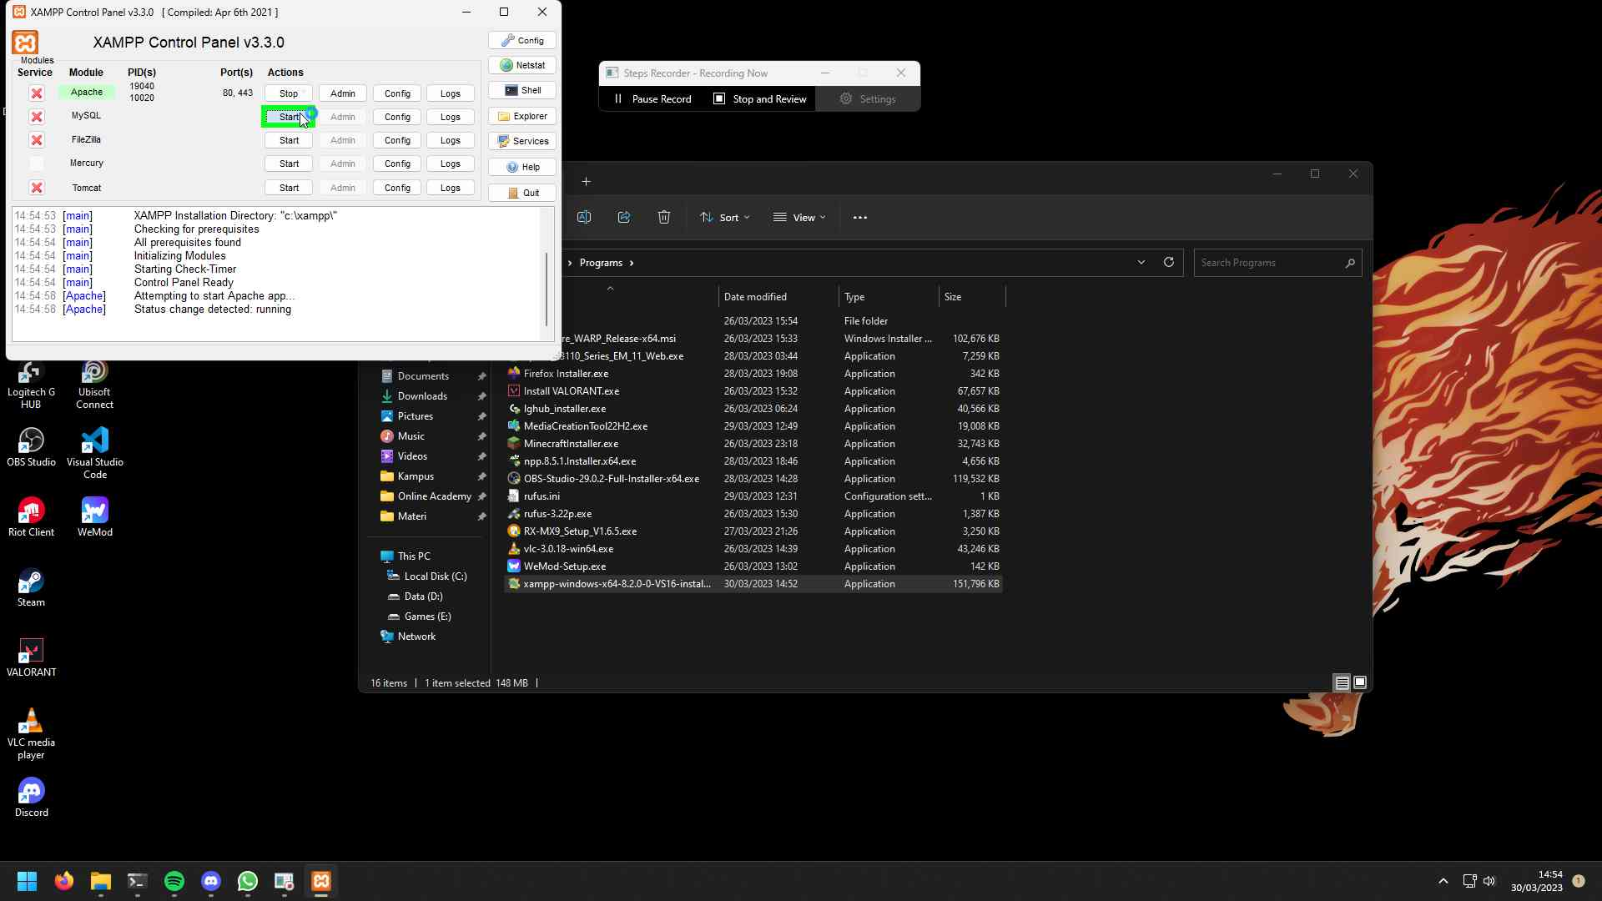Step 26 screenshot.

[Previous](#Step26" \o "Previous) [Next](#Step28" \o "Next)

**Step 27: (‎30/‎03/‎2023 14:55:01)** User left click on "Allow access (button)" in "Windows Security Alert"

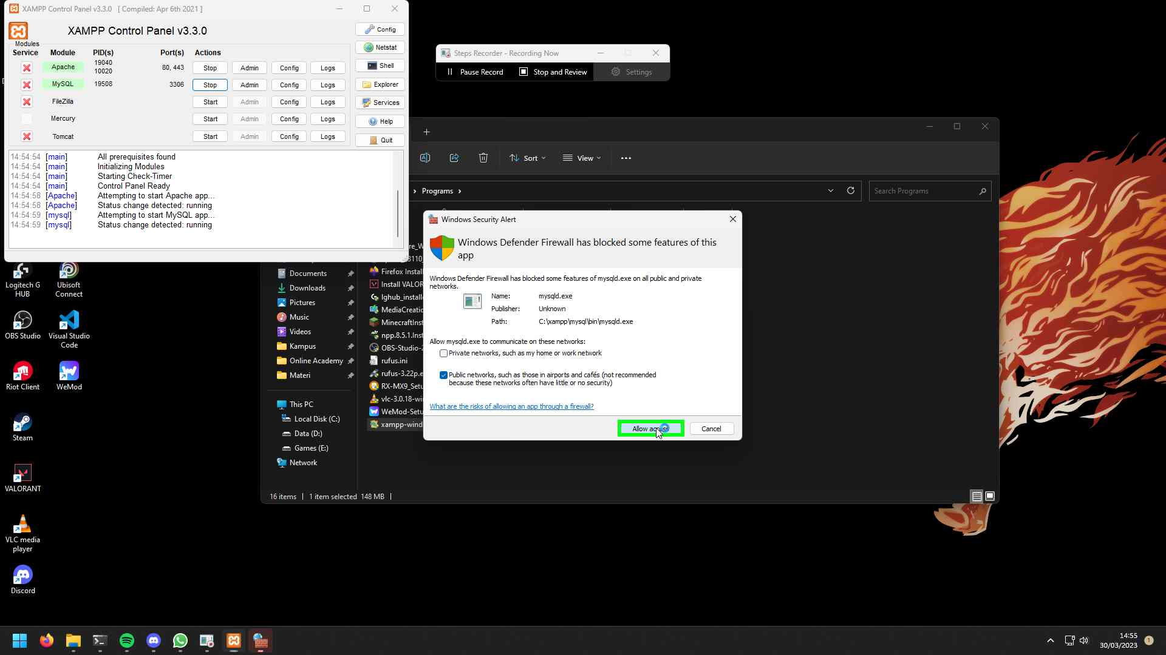Step 27 screenshot.

[Previous](#Step27" \o "Previous) [Next](#Step29" \o "Next)

**Step 28: (‎30/‎03/‎2023 14:55:03)** User left click on "Firefox (button)"

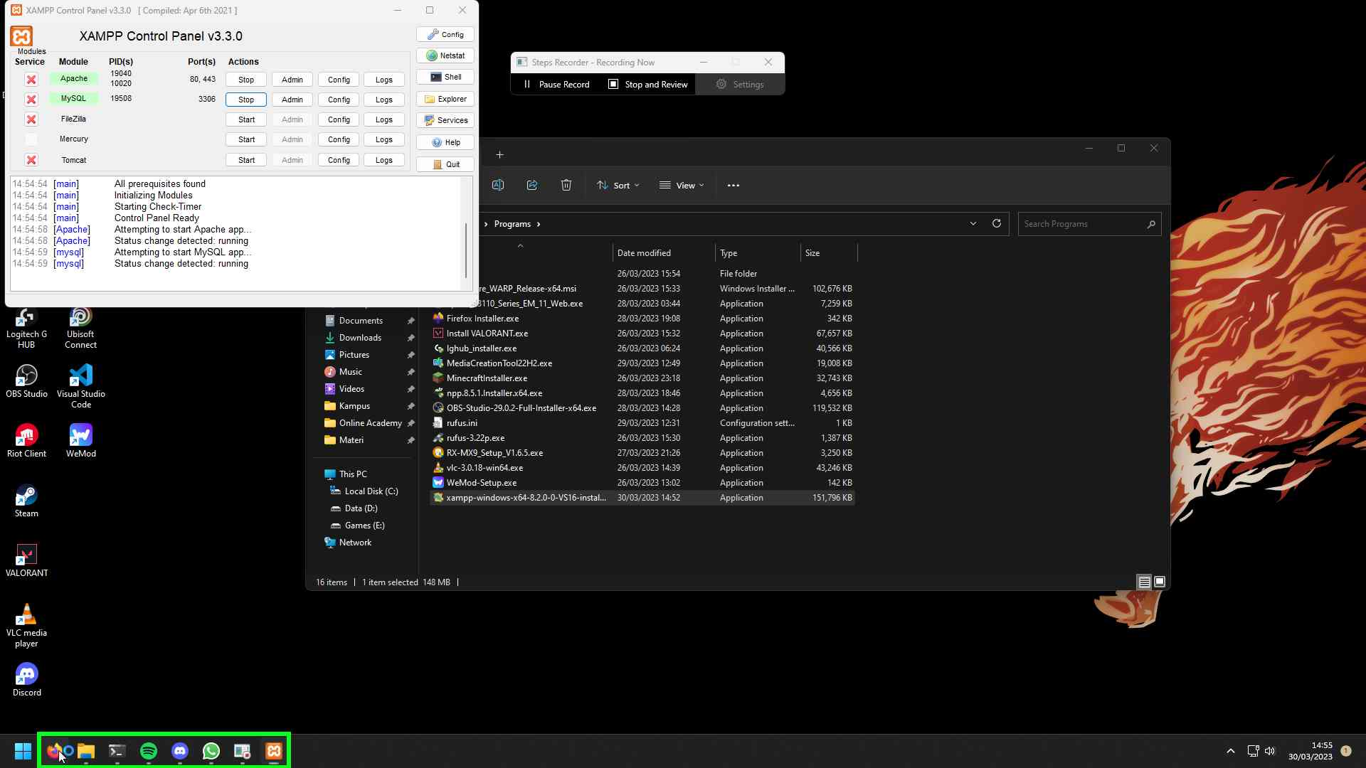Step 28 screenshot.

[Previous](#Step28" \o "Previous) [Next](#Step30" \o "Next)

**Step 29: (‎30/‎03/‎2023 14:55:05)** User left click on "Search with Google or enter address (edit)" in "Google — Mozilla Firefox"

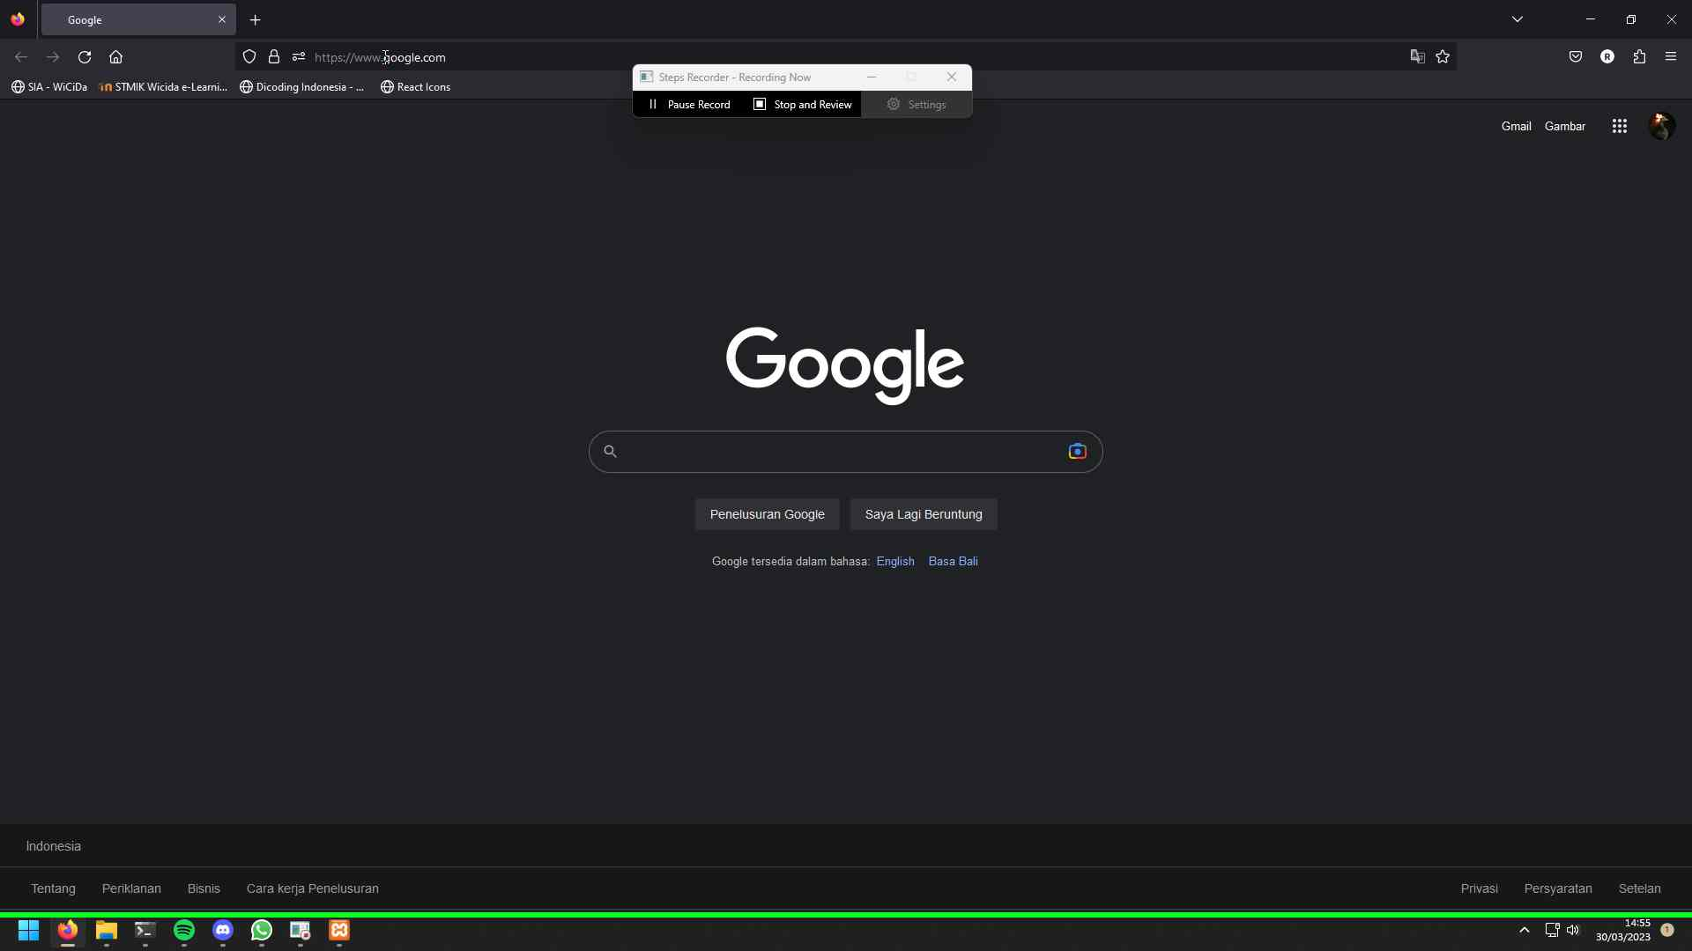Step 29 screenshot.

[Previous](#Step29" \o "Previous) [Next](#Step31" \o "Next)

**Step 30: (‎30/‎03/‎2023 14:55:06)** User keyboard input on "Google — Mozilla Firefox (window)" in "Google — Mozilla Firefox" [... Enter]

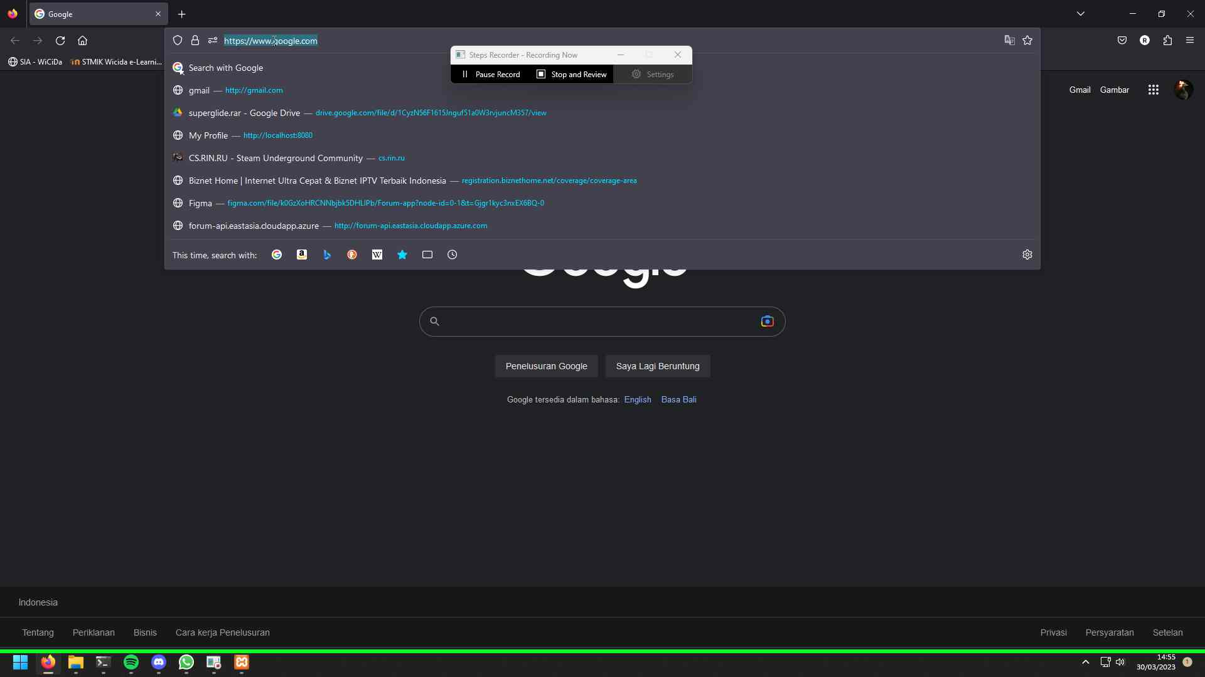Step 30 screenshot.

[Previous](#Step30" \o "Previous) [Next](#Step32" \o "Next)

**Step 31: (‎30/‎03/‎2023 14:55:11)** User left click on "Search with Google or enter address (edit)" in "Welcome to XAMPP — Mozilla Firefox"

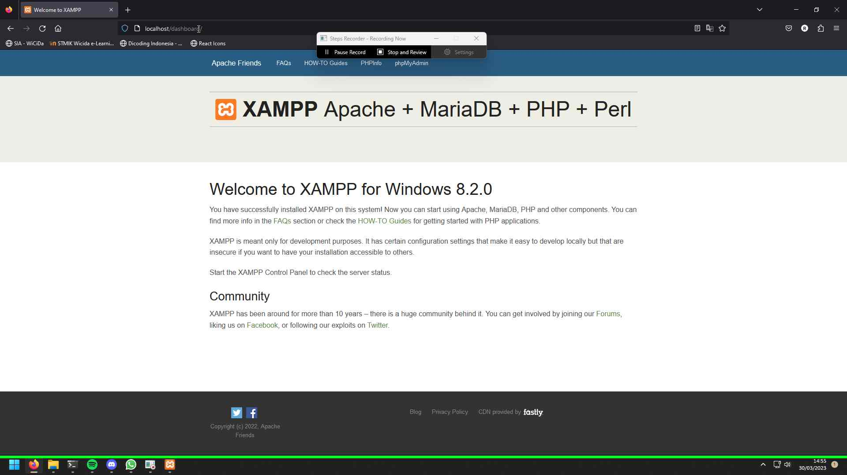Step 31 screenshot.

[Previous](#Step31" \o "Previous) [Next](#Step33" \o "Next)

**Step 32: (‎30/‎03/‎2023 14:55:11)** User mouse drag start on "Search with Google or enter address (edit)" in "Welcome to XAMPP — Mozilla Firefox"

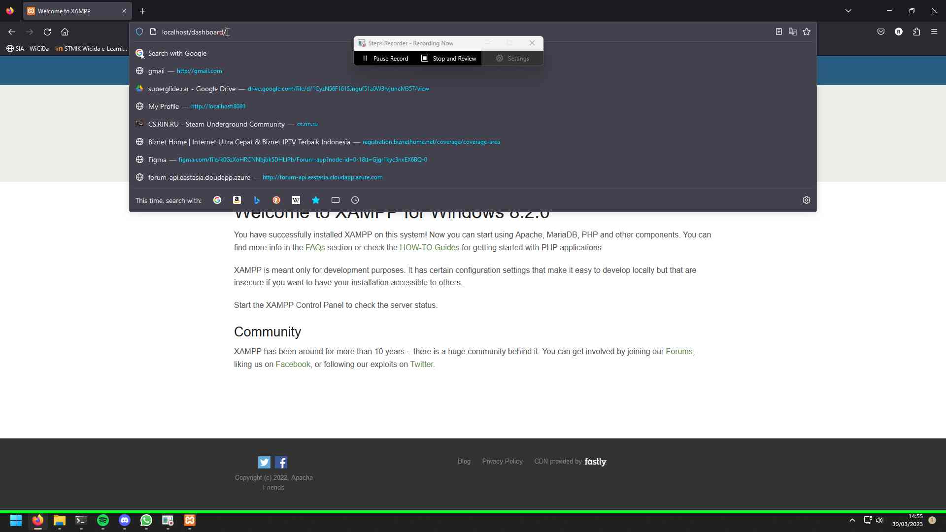Step 32 screenshot.

[Previous](#Step32" \o "Previous) [Next](#Step34" \o "Next)

**Step 33: (‎30/‎03/‎2023 14:55:13)** User mouse drag end on "Search with Google or enter address (edit)" in "Welcome to XAMPP — Mozilla Firefox"

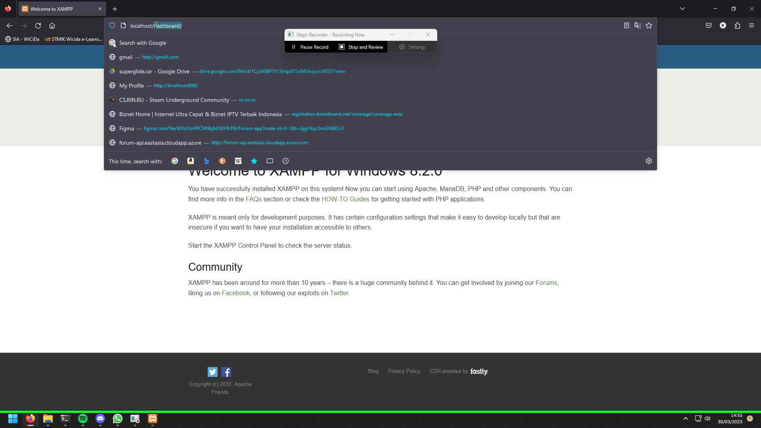Step 33 screenshot.

[Previous](#Step33" \o "Previous)

**Step 34: (‎30/‎03/‎2023 14:55:13)** User keyboard input on "Welcome to XAMPP — Mozilla Firefox (window)" in "Welcome to XAMPP — Mozilla Firefox" [... Enter]

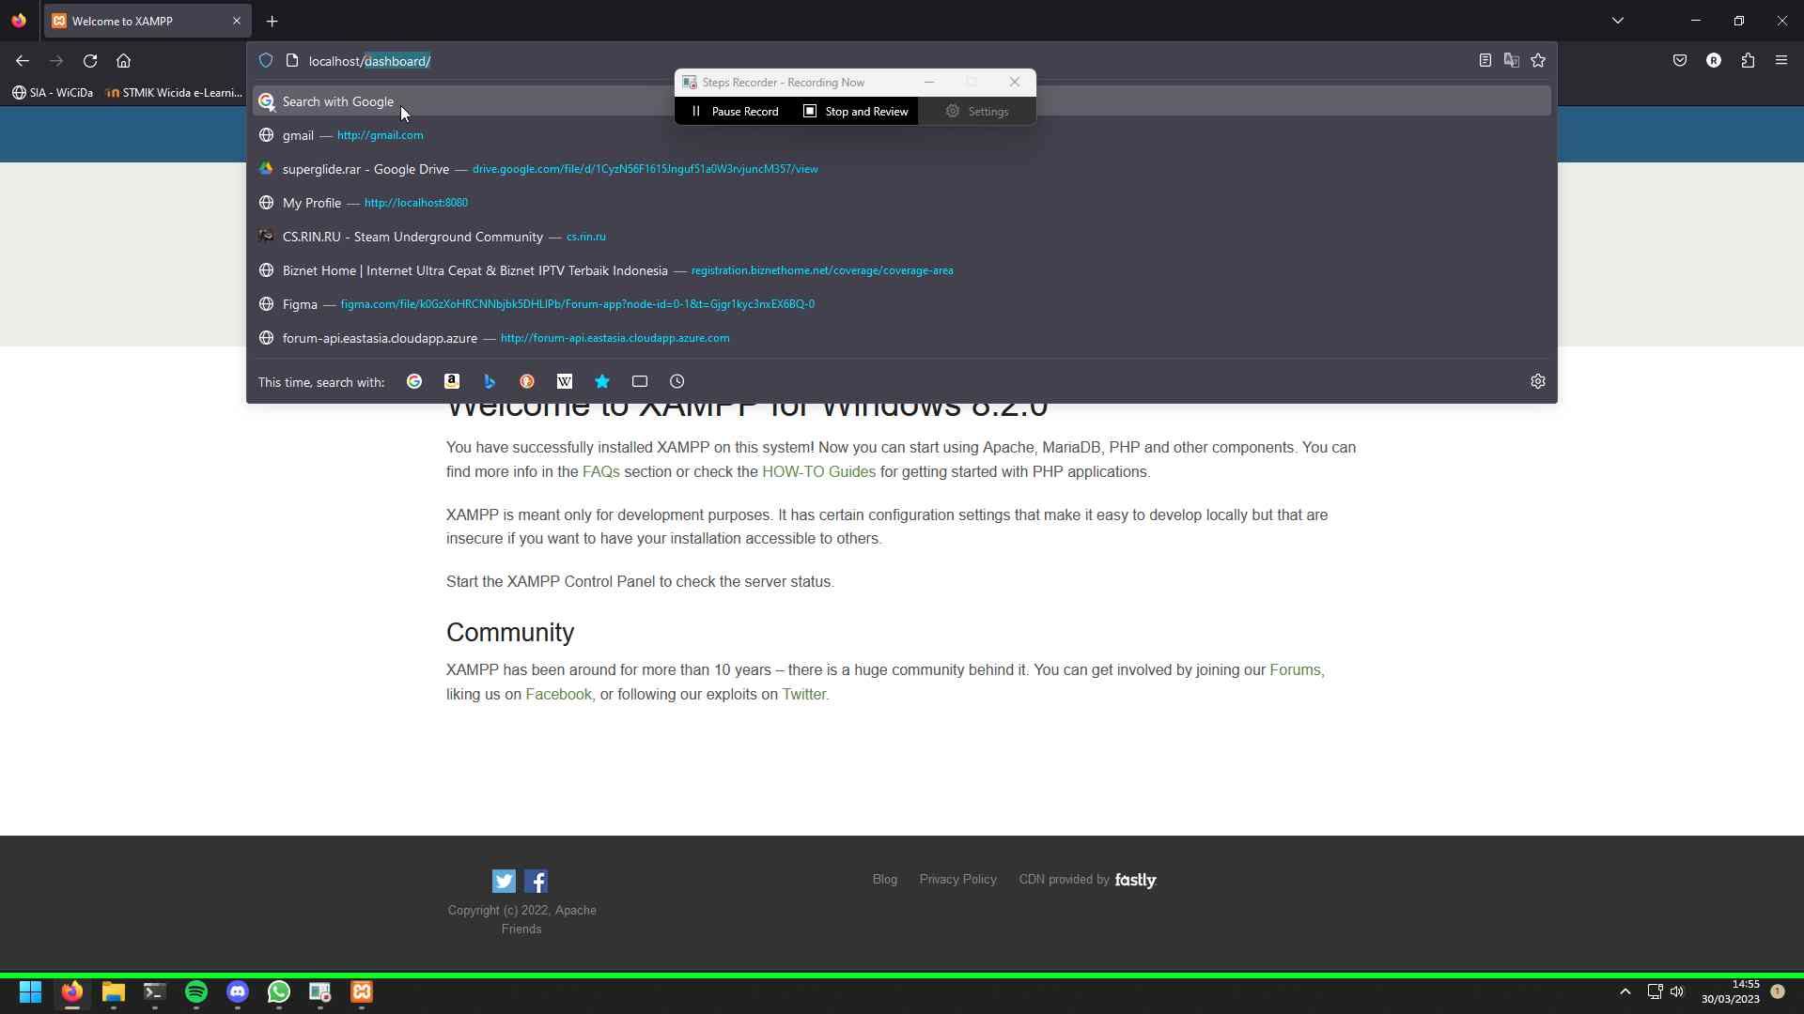Step 34 screenshot.

# Additional Details

The following section contains the additional details that were recorded.

These details help accurately identify the programs and UI you used in this recording.

This section may contain text that is internal to programs that only very advanced users or programmers may understand.

Please review these details to ensure that they do not contain any information that you would not like others to see.

Recording Session: ‎30/‎03/‎2023 14:51:05 - 14:55:19  
  
Recorded Steps: 34, Missed Steps: 0, Other Errors: 0  
  
Operating System: 22621.1.amd64fre.ni_release.220506-1250 10.0.0.0.2.48  
  
Step 1: User left click on "Firefox (button)"  
Program: Windows Explorer, 10.0.22621.1411 (WinBuild.160101.0800), Microsoft Corporation, EXPLORER.EXE, EXPLORER.EXE  
UI Elements: Firefox, Taskbar.TaskListButtonAutomationPeer, Taskbar.TaskbarFrameAutomationPeer, Windows.UI.Input.InputSite.WindowClass, DesktopWindowXamlSource, Windows.UI.Composition.DesktopWindowContentBridge, Taskbar, Shell_TrayWnd  
  
Step 2: User left click on "Google — Mozilla Firefox (window)" in "Google — Mozilla Firefox"  
Program: Firefox, 111.0.1, Mozilla Corporation, FIREFOX.EXE, FIREFOX.EXE  
UI Elements: Google — Mozilla Firefox, MozillaWindowClass  
  
Step 3: User keyboard input on "Google — Mozilla Firefox (window)" in "Google — Mozilla Firefox" [... Enter]  
Program: Firefox, 111.0.1, Mozilla Corporation, FIREFOX.EXE, FIREFOX.EXE  
UI Elements: Google — Mozilla Firefox, MozillaWindowClass  
  
Step 4: User left click in "xampp - Penelusuran Google — Mozilla Firefox"  
Program: Firefox, 111.0.1, Mozilla Corporation, FIREFOX.EXE, FIREFOX.EXE  
UI Elements:   
  
Step 5: User left click in "Download XAMPP — Mozilla Firefox"  
Program: Firefox, 111.0.1, Mozilla Corporation, FIREFOX.EXE, FIREFOX.EXE  
UI Elements:   
  
Step 6: User left double click on "Name (edit)" in "Programs"  
Program: Windows Explorer, 10.0.22621.1411 (WinBuild.160101.0800), Microsoft Corporation, EXPLORER.EXE, EXPLORER.EXE  
UI Elements: Name, UIProperty, xampp-windows-x64-8.2.0-0-VS16-installer.exe, UIItem, Items View, UIItemsView, Shell Folder View, DUIListView, Folder Layout Pane, Element, Explorer Pane, HWNDView, DUIViewWndClassName, Programs, ShellTabWindowClass, Programs, CabinetWClass  
  
Step 7: User left click on "OK (button)" in "Warning"  
Program: 1.0.0.0, Apache Friends, XAMPP-WINDOWS-X64-8.2.0-0-VS16-INSTALLER.EXE, XAMPP-WINDOWS-X64-8.2.0-0-VS16-INSTALLER.EXE  
UI Elements: OK, Button, Warning, #32770  
  
Step 8: User left click on "Setup (window)" in "Setup"  
Program: 1.0.0.0, Apache Friends, XAMPP-WINDOWS-X64-8.2.0-0-VS16-INSTALLER.EXE, XAMPP-WINDOWS-X64-8.2.0-0-VS16-INSTALLER.EXE  
UI Elements: TkChild, TkChild, TkChild, TkChild, Setup, TkTopLevel  
  
Step 9: User mouse wheel down on "Setup (window)" in "Setup"  
Program: 1.0.0.0, Apache Friends, XAMPP-WINDOWS-X64-8.2.0-0-VS16-INSTALLER.EXE, XAMPP-WINDOWS-X64-8.2.0-0-VS16-INSTALLER.EXE  
UI Elements: TkChild, TkChild, TkChild, TkChild, TkChild, TkChild, TkChild, TkChild, Setup, TkTopLevel  
  
Step 10: User mouse drag start on "Position (thumb)" in "Setup"  
Program: 1.0.0.0, Apache Friends, XAMPP-WINDOWS-X64-8.2.0-0-VS16-INSTALLER.EXE, XAMPP-WINDOWS-X64-8.2.0-0-VS16-INSTALLER.EXE  
UI Elements: Position, ScrollBar, TkChild, TkChild, TkChild, TkChild, TkChild, TkChild, Setup, TkTopLevel  
  
Step 11: User mouse drag end on "Line down (button)" in "Setup"  
Program: 1.0.0.0, Apache Friends, XAMPP-WINDOWS-X64-8.2.0-0-VS16-INSTALLER.EXE, XAMPP-WINDOWS-X64-8.2.0-0-VS16-INSTALLER.EXE  
UI Elements: Line down, ScrollBar, TkChild, TkChild, TkChild, TkChild, TkChild, TkChild, Setup, TkTopLevel  
  
Step 12: User left click on "Setup (window)" in "Setup"  
Program: 1.0.0.0, Apache Friends, XAMPP-WINDOWS-X64-8.2.0-0-VS16-INSTALLER.EXE, XAMPP-WINDOWS-X64-8.2.0-0-VS16-INSTALLER.EXE  
UI Elements: TkChild, TkChild, TkChild, TkChild, Setup, TkTopLevel  
  
Step 13: User left double click on "Setup (window)" in "Setup"  
Program: 1.0.0.0, Apache Friends, XAMPP-WINDOWS-X64-8.2.0-0-VS16-INSTALLER.EXE, XAMPP-WINDOWS-X64-8.2.0-0-VS16-INSTALLER.EXE  
UI Elements: TkChild, TkChild, TkChild, TkChild, TkChild, TkChild, TkChild, TkChild, Setup, TkTopLevel  
  
Step 14: User mouse drag end on "Setup (window)" in "Setup"  
Program: 1.0.0.0, Apache Friends, XAMPP-WINDOWS-X64-8.2.0-0-VS16-INSTALLER.EXE, XAMPP-WINDOWS-X64-8.2.0-0-VS16-INSTALLER.EXE  
UI Elements: TkChild, TkChild, TkChild, TkChild, TkChild, TkChild, TkChild, TkChild, Setup, TkTopLevel  
  
Step 15: User left click on "Setup (window)" in "Setup"  
Program: 1.0.0.0, Apache Friends, XAMPP-WINDOWS-X64-8.2.0-0-VS16-INSTALLER.EXE, XAMPP-WINDOWS-X64-8.2.0-0-VS16-INSTALLER.EXE  
UI Elements: TkChild, TkChild, TkChild, TkChild, Setup, TkTopLevel  
  
Step 16: User left click on "Setup (window)" in "Setup"  
Program: 1.0.0.0, Apache Friends, XAMPP-WINDOWS-X64-8.2.0-0-VS16-INSTALLER.EXE, XAMPP-WINDOWS-X64-8.2.0-0-VS16-INSTALLER.EXE  
UI Elements: TkChild, TkChild, TkChild, TkChild, Setup, TkTopLevel  
  
Step 17: User left click on "Setup (window)" in "Setup"  
Program: 1.0.0.0, Apache Friends, XAMPP-WINDOWS-X64-8.2.0-0-VS16-INSTALLER.EXE, XAMPP-WINDOWS-X64-8.2.0-0-VS16-INSTALLER.EXE  
UI Elements: TkChild, TkChild, TkChild, TkChild, Setup, TkTopLevel  
  
Step 18: User left click on "Allow access (button)" in "Windows Security Alert"  
Program: Windows host process (Rundll32), 10.0.22621.1 (WinBuild.160101.0800), Microsoft Corporation, RUNDLL32.EXE C:\WINDOWS\SYSTEM32\FIREWALLCONTROLPANEL.DLL,SHOWNOTIFICATIONDIALOG /CONFIGURE /ETONLY 0 /ONPROFILES 6 /OTHERALLOWED 0 /OTHERBLOCKED 0 /OTHEREDGEALLOWED 0 /NEWBLOCKED 4 C:\XAMPP\APACHE\BIN\HTTPD.EXE, RUNDLL32.EXE  
UI Elements: Allow access, Button, Windows Security Alert, #32770  
  
Step 19: User left click on "Setup (window)" in "Setup"  
Program: 1.0.0.0, Apache Friends, XAMPP-WINDOWS-X64-8.2.0-0-VS16-INSTALLER.EXE, XAMPP-WINDOWS-X64-8.2.0-0-VS16-INSTALLER.EXE  
UI Elements: TkChild, TkChild, TkChild, TkChild, TkChild, Setup, TkTopLevel  
  
Step 20: User left click on "Setup (window)" in "Setup"  
Program: 1.0.0.0, Apache Friends, XAMPP-WINDOWS-X64-8.2.0-0-VS16-INSTALLER.EXE, XAMPP-WINDOWS-X64-8.2.0-0-VS16-INSTALLER.EXE  
UI Elements: TkChild, TkChild, TkChild, TkChild, Setup, TkTopLevel  
  
Step 21: User left click on "Start (button)"  
Program: Windows Explorer, 10.0.22621.1411 (WinBuild.160101.0800), Microsoft Corporation, EXPLORER.EXE, EXPLORER.EXE  
UI Elements: Start, ToggleButton, Taskbar.TaskbarFrameAutomationPeer, Windows.UI.Input.InputSite.WindowClass, DesktopWindowXamlSource, Windows.UI.Composition.DesktopWindowContentBridge, Taskbar, Shell_TrayWnd  
  
Step 22: User keyboard input on "Search (window)" in "Search" [...]  
Program: 623.1701.10.0, Microsoft Corporation, SEARCHHOST.EXE -SERVERNAME:CORTANAUI.APPXSTMWAAB17Q5S3Y22TP6APQZ7A45VWV65.MCA, SEARCHHOST.EXE  
UI Elements: Search, Windows.UI.Core.CoreWindow, Start, Windows.UI.Core.CoreWindow  
  
Step 23: User right click on "XAMPP Control Panel, App, Press right to switch preview (list item)" in "Search"  
Program: 623.1701.10.0, Microsoft Corporation, SEARCHHOST.EXE -SERVERNAME:CORTANAUI.APPXSTMWAAB17Q5S3Y22TP6APQZ7A45VWV65.MCA, SEARCHHOST.EXE  
UI Elements: XAMPP Control Panel, App, Press right to switch preview, Results, Bing, Bing, WebView, Search, Windows.UI.Core.CoreWindow  
  
Step 24: User left click on "Run as administrator (list item)" in "Search"  
Program: 623.1701.10.0, Microsoft Corporation, SEARCHHOST.EXE -SERVERNAME:CORTANAUI.APPXSTMWAAB17Q5S3Y22TP6APQZ7A45VWV65.MCA, SEARCHHOST.EXE  
UI Elements: Run as administrator, Context Menu, Bing, Bing, WebView, Search, Windows.UI.Core.CoreWindow  
  
Step 25: User left click on "Start (button)" in "XAMPP Control Panel v3.3.0 [ Compiled: Apr 6th 2021 ]"  
Program: 3.3.0.0, XAMPP-CONTROL.EXE, XAMPP-CONTROL.EXE  
UI Elements: Start, TBitBtn, Modules , TGroupBox, XAMPP Control Panel v3.3.0 [ Compiled: Apr 6th 2021 ], TfMain  
  
Step 26: User left click on "Start (button)" in "XAMPP Control Panel v3.3.0 [ Compiled: Apr 6th 2021 ]"  
Program: 3.3.0.0, XAMPP-CONTROL.EXE, XAMPP-CONTROL.EXE  
UI Elements: Start, TBitBtn, Modules , TGroupBox, XAMPP Control Panel v3.3.0 [ Compiled: Apr 6th 2021 ], TfMain  
  
Step 27: User left click on "Allow access (button)" in "Windows Security Alert"  
Program: Windows host process (Rundll32), 10.0.22621.1 (WinBuild.160101.0800), Microsoft Corporation, RUNDLL32.EXE C:\WINDOWS\SYSTEM32\FIREWALLCONTROLPANEL.DLL,SHOWNOTIFICATIONDIALOG /CONFIGURE /ETONLY 0 /ONPROFILES 6 /OTHERALLOWED 0 /OTHERBLOCKED 0 /OTHEREDGEALLOWED 0 /NEWBLOCKED 4 C:\XAMPP\MYSQL\BIN\MYSQLD.EXE, RUNDLL32.EXE  
UI Elements: Allow access, Button, Windows Security Alert, #32770  
  
Step 28: User left click on "Firefox (button)"  
Program: Windows Explorer, 10.0.22621.1411 (WinBuild.160101.0800), Microsoft Corporation, EXPLORER.EXE, EXPLORER.EXE  
UI Elements: Firefox, Taskbar.TaskListButtonAutomationPeer, Taskbar.TaskbarFrameAutomationPeer, Windows.UI.Input.InputSite.WindowClass, DesktopWindowXamlSource, Windows.UI.Composition.DesktopWindowContentBridge, Taskbar, Shell_TrayWnd  
  
Step 29: User left click on "Search with Google or enter address (edit)" in "Google — Mozilla Firefox"  
Program: Firefox, 111.0.1, Mozilla Corporation, FIREFOX.EXE, FIREFOX.EXE  
UI Elements: Search with Google or enter address, Navigation, Google — Mozilla Firefox, MozillaWindowClass  
  
Step 30: User keyboard input on "Google — Mozilla Firefox (window)" in "Google — Mozilla Firefox" [... Enter]  
Program: Firefox, 111.0.1, Mozilla Corporation, FIREFOX.EXE, FIREFOX.EXE  
UI Elements: Google — Mozilla Firefox, MozillaWindowClass  
  
Step 31: User left click on "Search with Google or enter address (edit)" in "Welcome to XAMPP — Mozilla Firefox"  
Program: Firefox, 111.0.1, Mozilla Corporation, FIREFOX.EXE, FIREFOX.EXE  
UI Elements: Search with Google or enter address, Navigation, Welcome to XAMPP — Mozilla Firefox, MozillaWindowClass  
  
Step 32: User mouse drag start on "Search with Google or enter address (edit)" in "Welcome to XAMPP — Mozilla Firefox"  
Program: Firefox, 111.0.1, Mozilla Corporation, FIREFOX.EXE, FIREFOX.EXE  
UI Elements: Search with Google or enter address, Navigation, Welcome to XAMPP — Mozilla Firefox, MozillaWindowClass  
  
Step 33: User mouse drag end on "Search with Google or enter address (edit)" in "Welcome to XAMPP — Mozilla Firefox"  
Program: Firefox, 111.0.1, Mozilla Corporation, FIREFOX.EXE, FIREFOX.EXE  
UI Elements: Search with Google or enter address, Navigation, Welcome to XAMPP — Mozilla Firefox, MozillaWindowClass  
  
Step 34: User keyboard input on "Welcome to XAMPP — Mozilla Firefox (window)" in "Welcome to XAMPP — Mozilla Firefox" [... Enter]  
Program: Firefox, 111.0.1, Mozilla Corporation, FIREFOX.EXE, FIREFOX.EXE  
UI Elements: Welcome to XAMPP — Mozilla Firefox, MozillaWindowClass

[Return to top of page...](#ReportTop" \o "Return to top of page)